Welcome to the tutorial of Tranducer Output Visual Analysis (TOVA) developed by yours truly
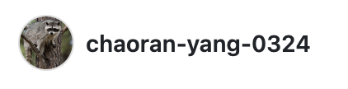GitHub

Preparation

Inputs:
- .ddf files of muscle contractions over time.
- muscle information (mass or cross-sectional area)

Outputs:
- Graph of peak power, isotonic work or isometric work over muscle contraction over time.
- CSV file of data that created that graph
- Validation (optional)

NB:
Your .ddf file should look like this:
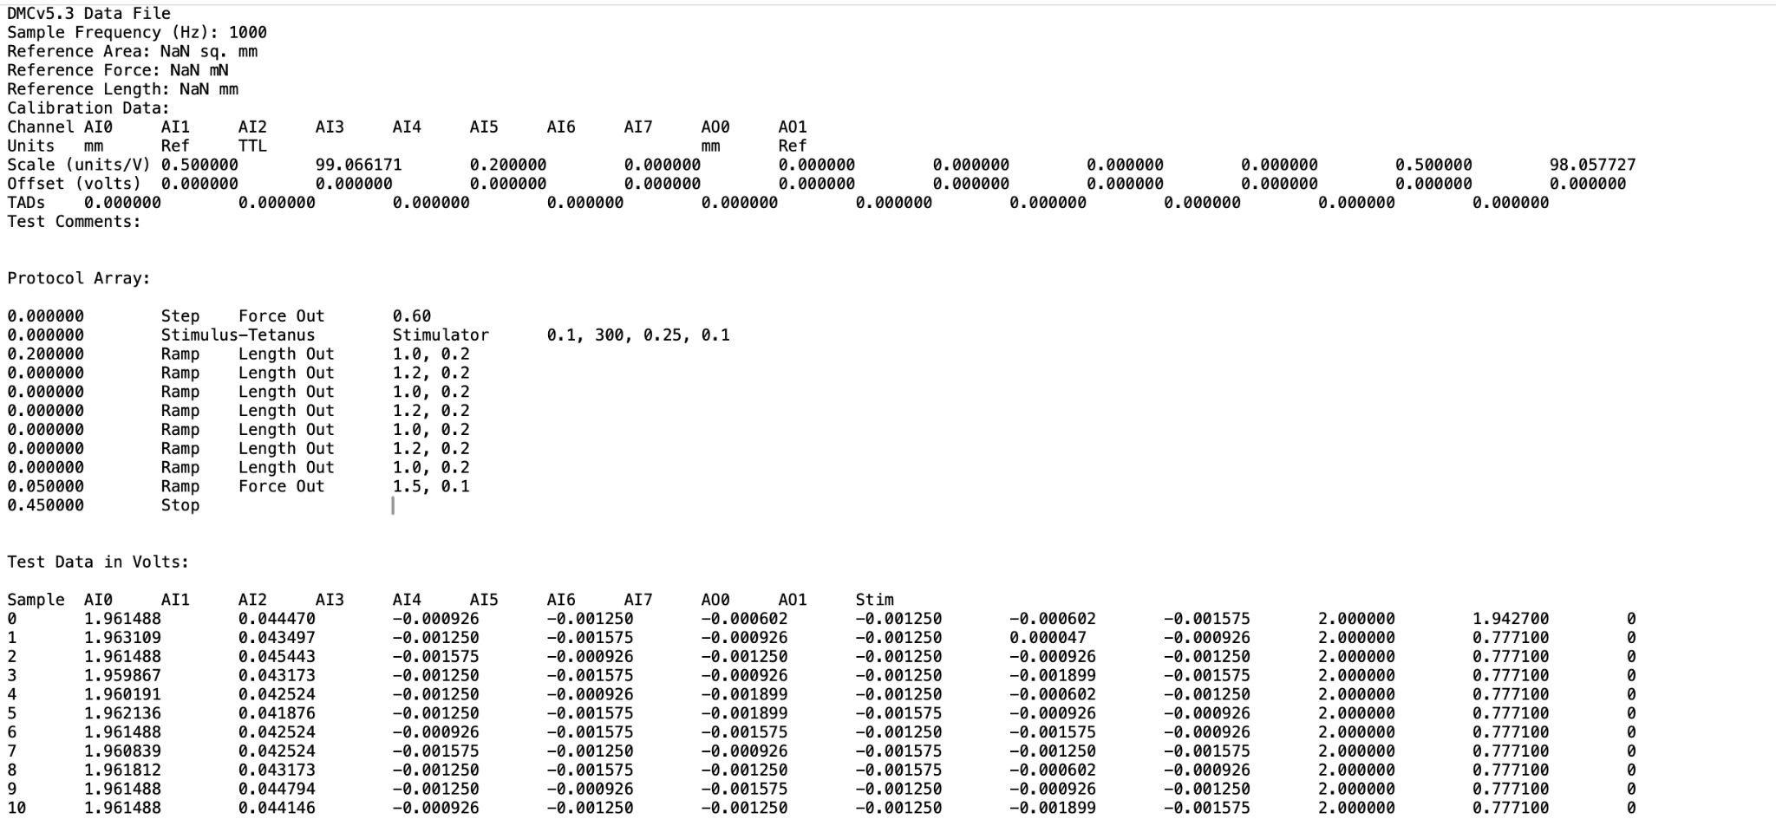

If you got your .ddf files directly from experiments, you should be good to go!

Analysis

— Begin by clicking on one of the app links —

Power: https://power0105.streamlit.app/
Isotonic: https://isotonicwork0120.streamlit.app/
Isometric: https://isometricwork0314.streamlit.app/

If you see something like this:
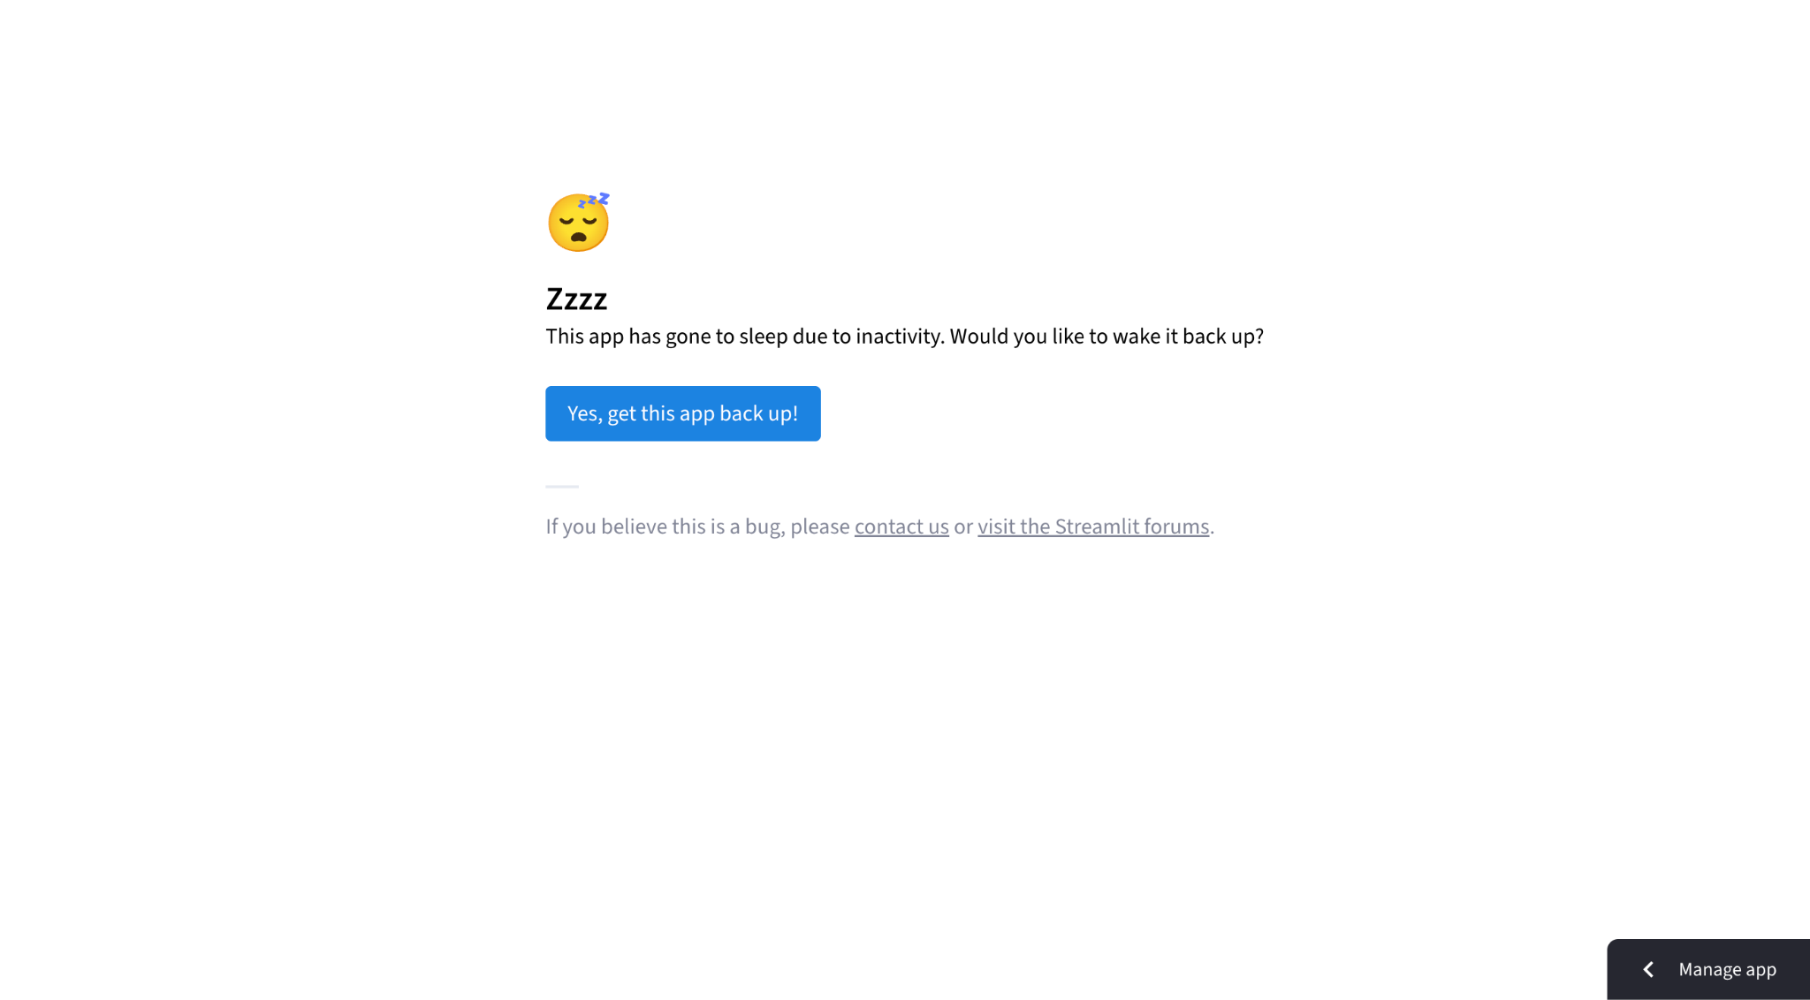
Please click “Yes, get this app back up!”

If you see …
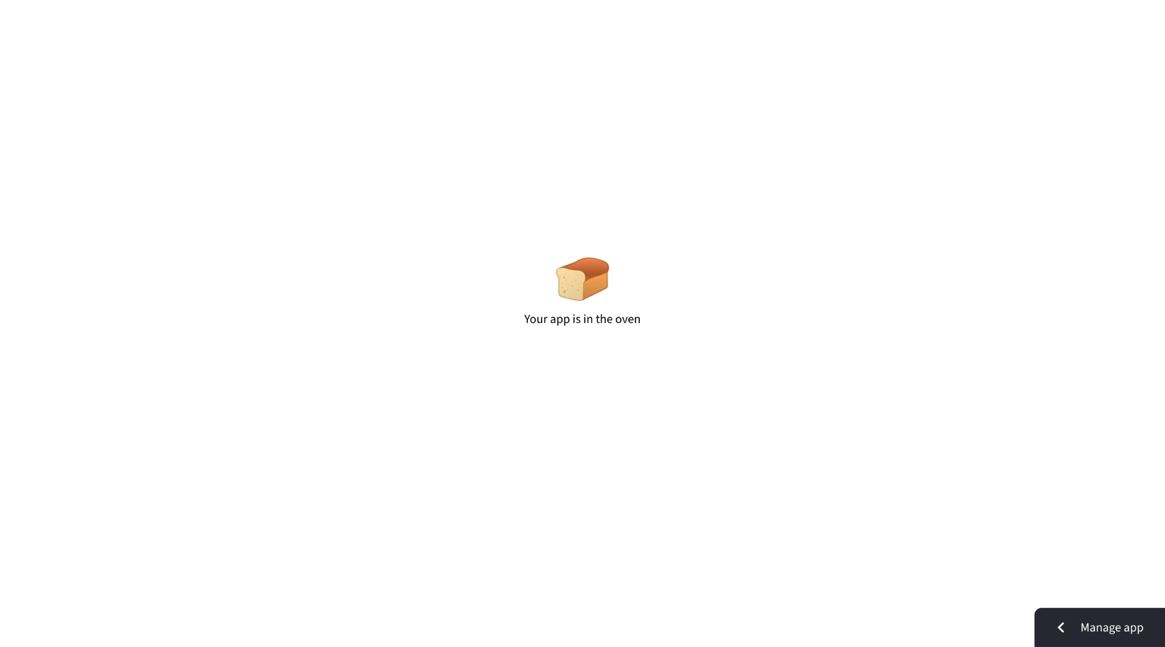
at the center of your screen
and/or …
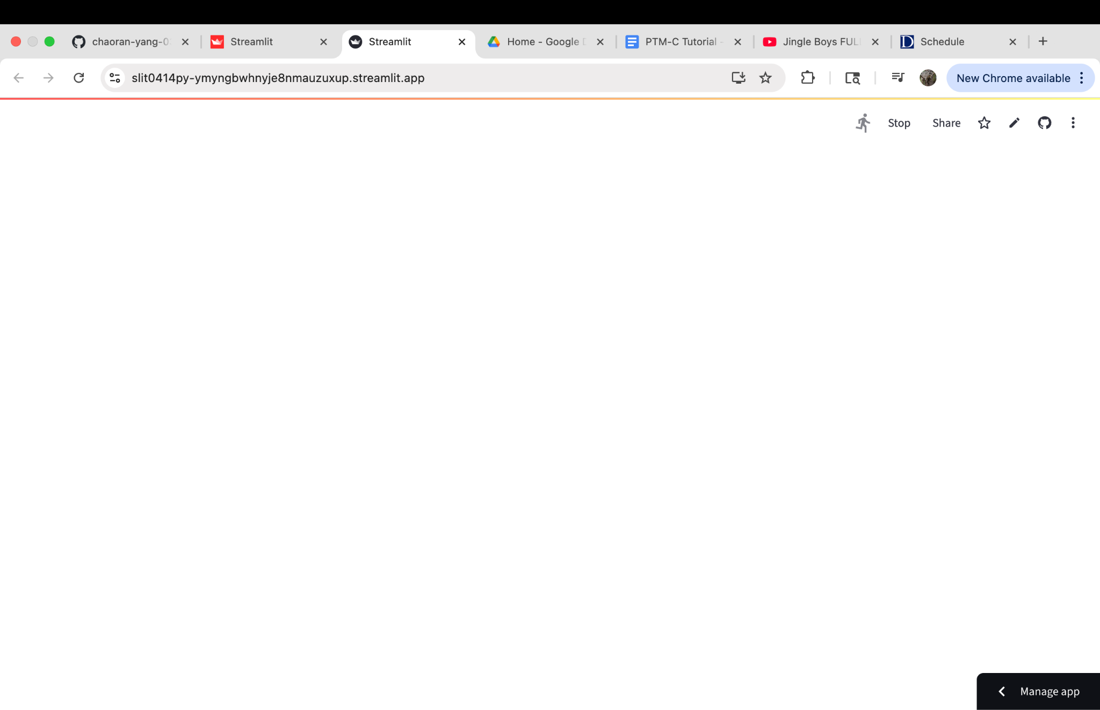
on the top right corner of your screen,

it means the app is awake and processing! It should be ready in less than 3 minutes.

If you see:
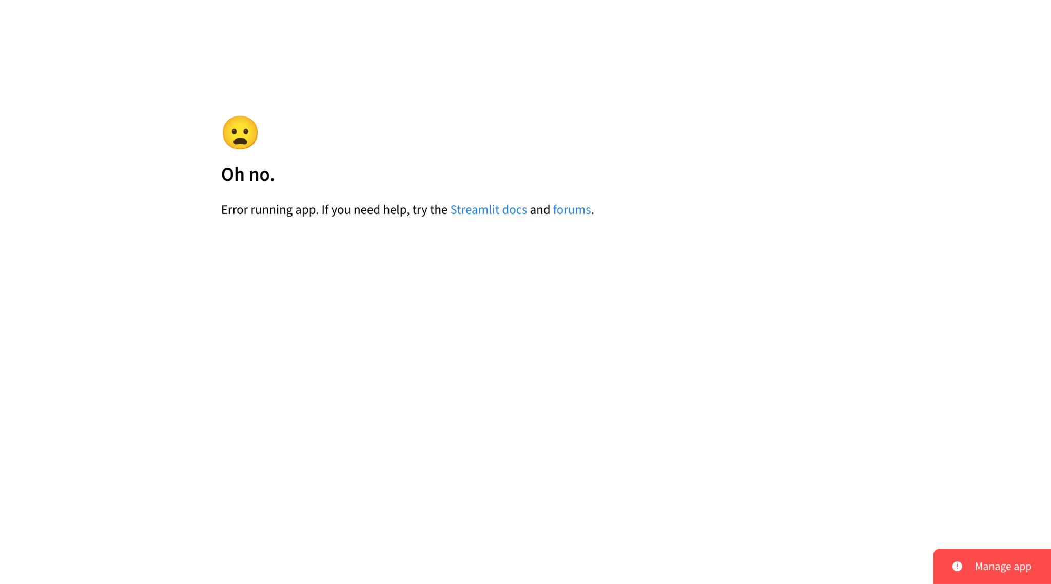
Please contact me (cy197@duke.edu, cyang8@uvm.edu, chaoran.ran.yang@gmail.com, or find me on LinkedIn) and I will (try to) do something about it.

If your app cooks successfully, you should see the interface…

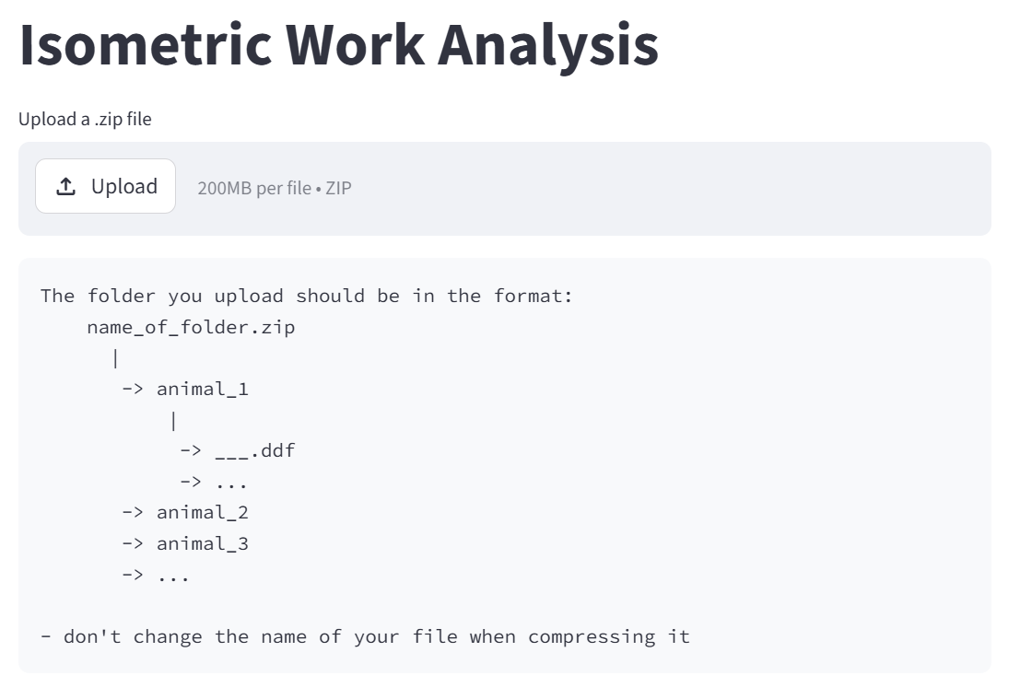

All three interfaces look similar, so I’m using isometric work as an example.

Your .zip file should contain folders of different series of contractions that you want to analyze on the same curve. In the example of above, we will get a graph with three curves, corresponding to animal_1, animal_2 and animal_3, respectively.

The exact name of your folders do not matter.

If your upload is successful, you will see…

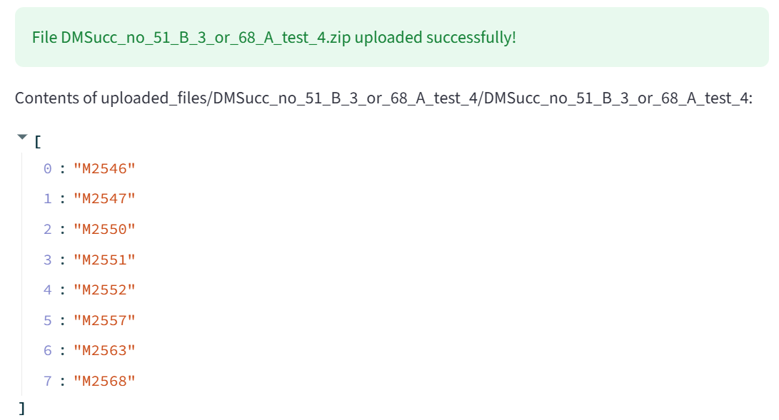
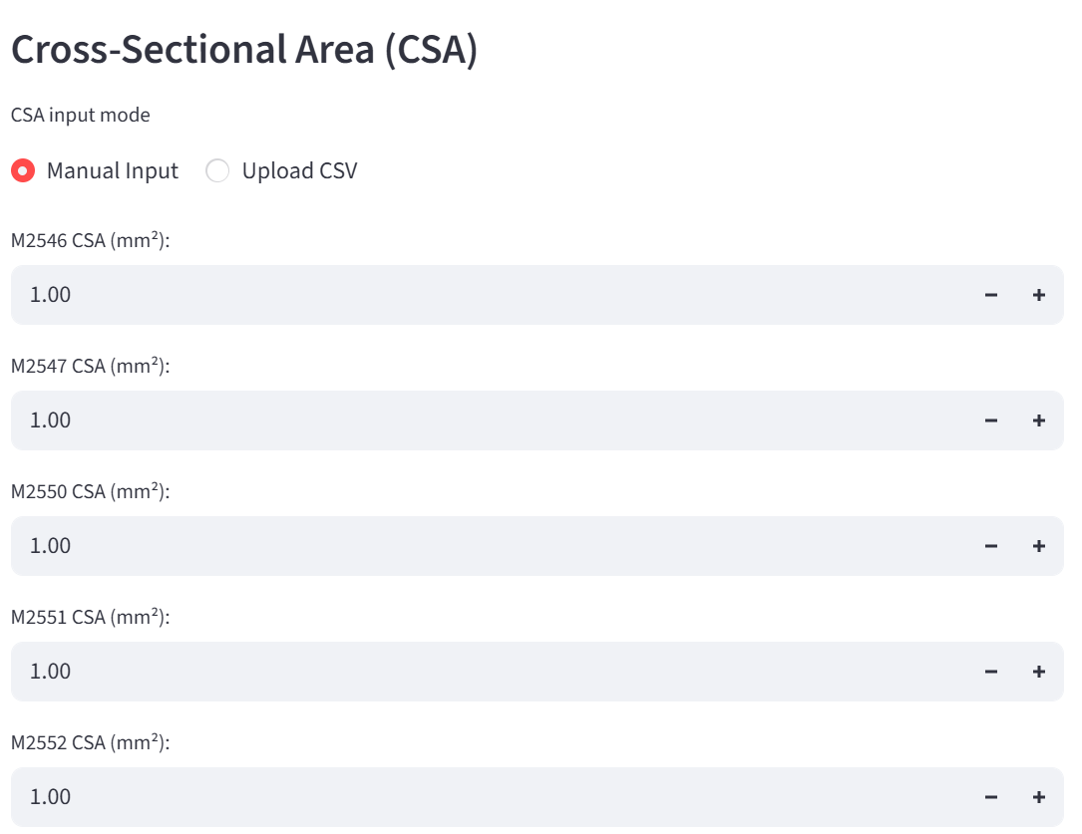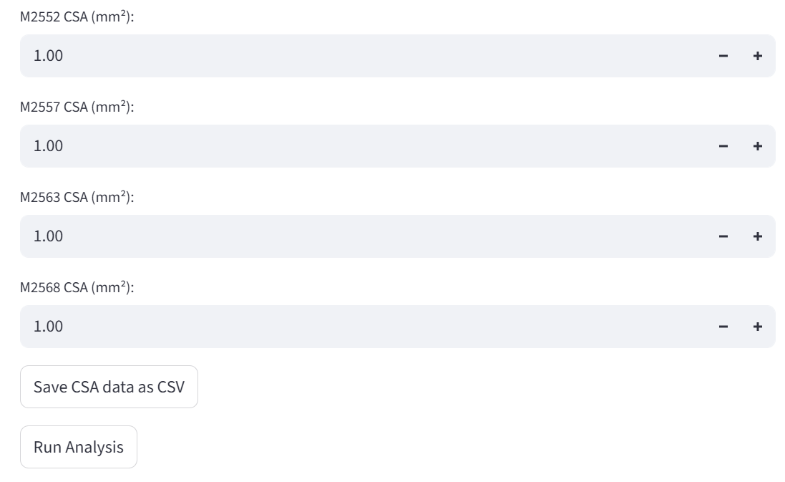

To input mass or CSA data, you have two options.
- Manually input to the interface
- Upload a CSV file with this format:

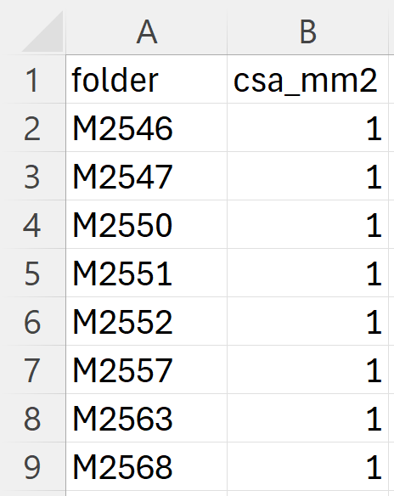
After you manually input data to the interface, you have the option to save your data as a CSV file, so that you don’t have to manually input the data if you choose to run these folders again.

Click “Run Analysis” to run analysis.

Results

If successful, you will receive a plot from the interface, followed by the button “Download CSV,” with which you can download the data used to generate the plot.

For peak power, your CSV file will have two columns: Folder Name and Peak Power (W/kg).

For isotonic work, your CSV file will have three columns: Folder Name, Isotonic Work (W/kg), and Jump Thershold Used. If Jump Thershold is blank, it means that the system is very confident that isotonic work has been properly calculated, and no precautions are needed. If there is a number input here, it means that the algorithm is not confident. The lower this number, the noisier the power profile. Generally, if there’s a number input here, I suggest you validate that result (see section below).

For isometric work, your CSV file will have three columns: Folder Name, Isometric Work (mN * s/mm^2) and Plateau Drift. If Plateau Drift is blank, it means that the system detects that the plateau region of the force profile is approximately flat. If there’s an asterisk here, it means that the plateau does not appear flat, which may have impacted endpoint detection for the isometric force integration.

Validation

For all three interfaces, after generating results, you have the option of checking the length, force and power profiles for specific contractions that you are suspicious of, or a random folder, if you’re doing a generic quality check.

Notes

Make sure the compressed zip file has the same name as the uncomprossed folder

Baseline cannot be less than 0.08 seconds

Plateau cannot be less than 0.05 seconds

Contraction should last more than 0.025 seconds; otherwise it will be flagged

One contraction per ddf file

Too many iterations fail

